CSV Implementation Walkthrough
Introduction
This is a walkthrough for modifying any questions within the Oral Medicine Game made for the SIU School of Dental Medicine. This does not include adding additional questions to the game as this will only be modifying the text scripts for the multiple choice questions before the diagnosis and medicine. If you wish to add additional questions, you will need to open the project in a Unity Editor (Recommended to use the original editor, 2021.3.33f1).
CSV Structure
Included in the “Website” folder (SIUE-SDM-Game\Website) is an excel spreadsheet that already contains the structure for which you can modify the questions, “template.csv”, including level ids, answers, feedback, etc.
The questions collum is where the dialogue and question are contained. In order to format the dialogue and question to fit within the textbox, the text will need to be written in a separate text or word document and copied into the formula bar to avoid lines stretching out of the text box. Keep each line to no more than 175 characters (including spaces). For a text document, notepad is able to read the characters, after highlighting the line, in the bottom left corner. For Word, you are able to highlight the text and click on the word counter to find the amount of characters including spaces.
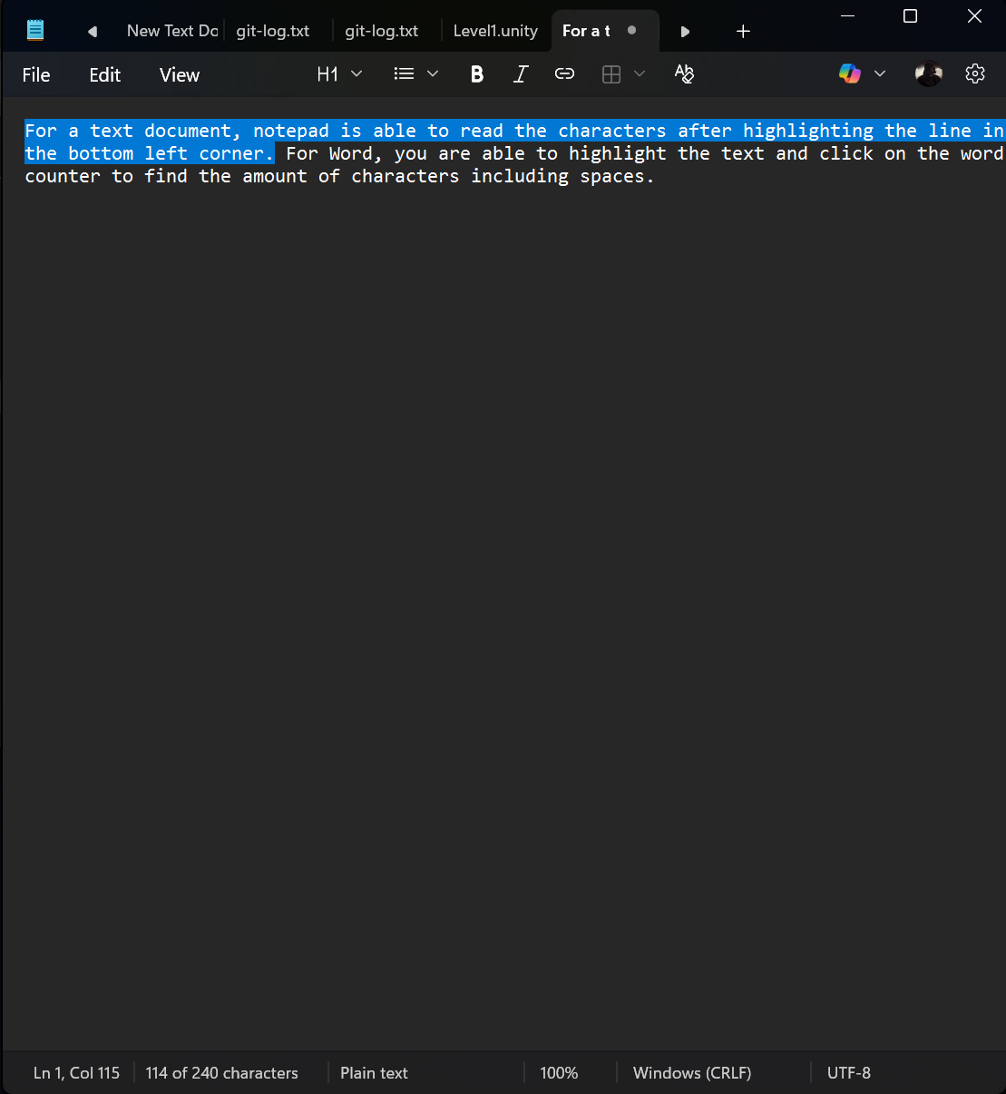
Figure 1 Notepad Character Count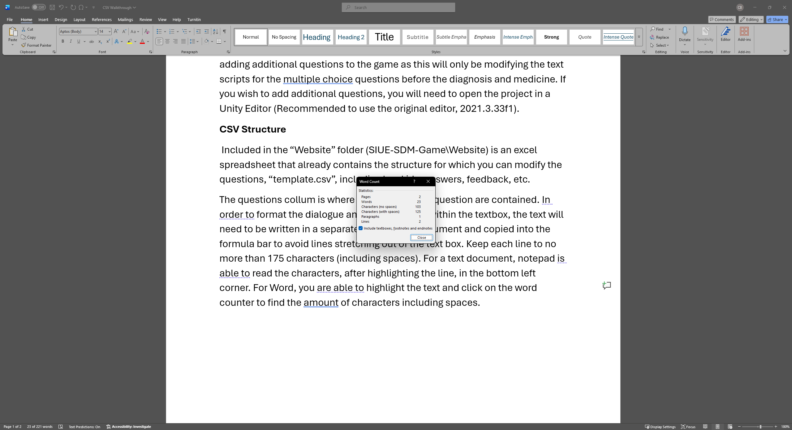
Figure 2 Word Character Count

After getting the dialogue and question in the format you wish, copy and paste them into the formula bar AS A WHOLE, into the appropriate question cell. The dialogue and question should retain the format after expanding the cell.
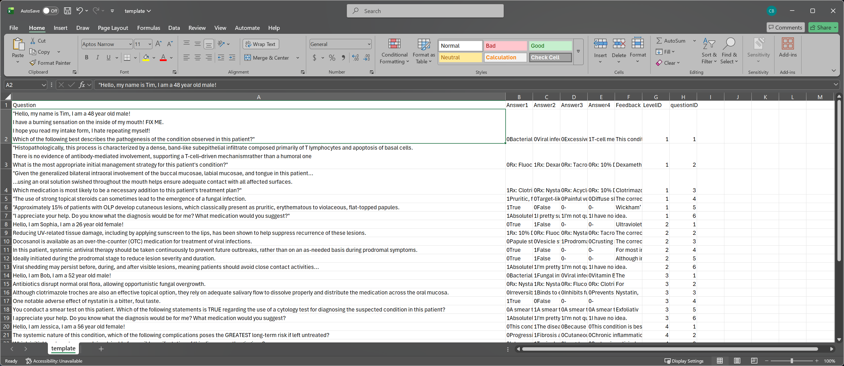
Answers for each question should include a 1 or 0 bit (True or False, Right or Wrong, etc.) value right before the answer for the question to be scored correctly. Each answer should be limited to 100 characters in order to fit the buttons.
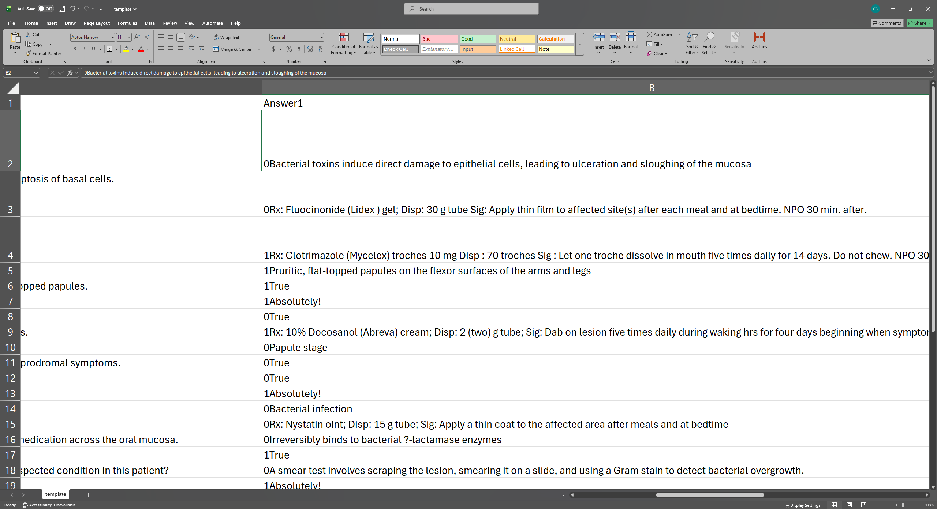
Feedback/explanation will need to be limited to one line at 175 characters. If you wish to have more lines for feedback you can bypass this by including it before the dialogue and question in the next question.
Level ID and Question ID include the number for the level and question number to differentiate between each question and level. These columns only require an integer.
CSV Upload
Now that the modified question is put in the spreadsheet the file will need to be exported as a .csv file or the page will not accept the file. To do this click File>Export>Change File Type>CSV(Comma delimited)>Save As 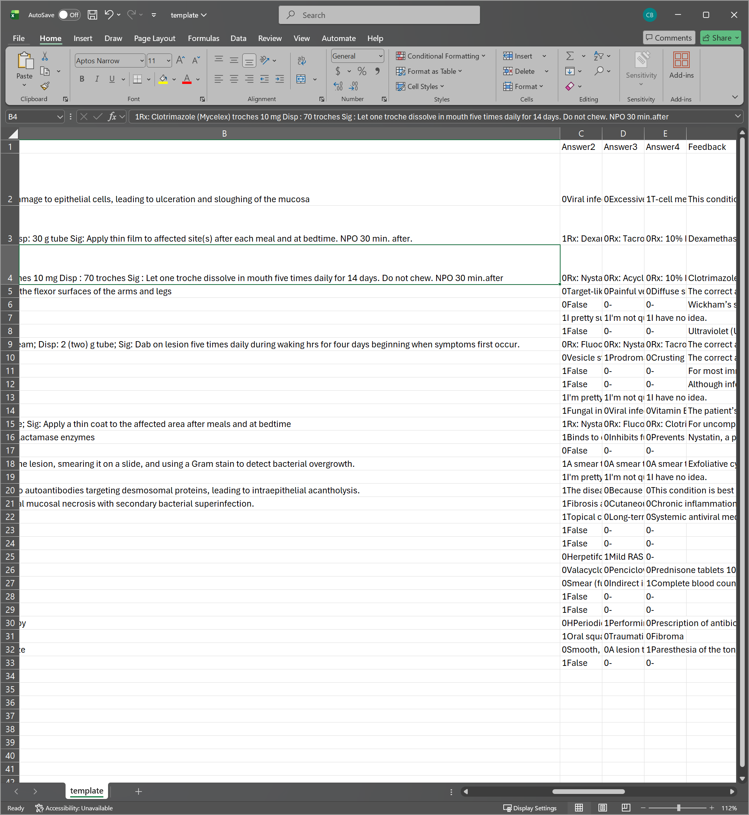
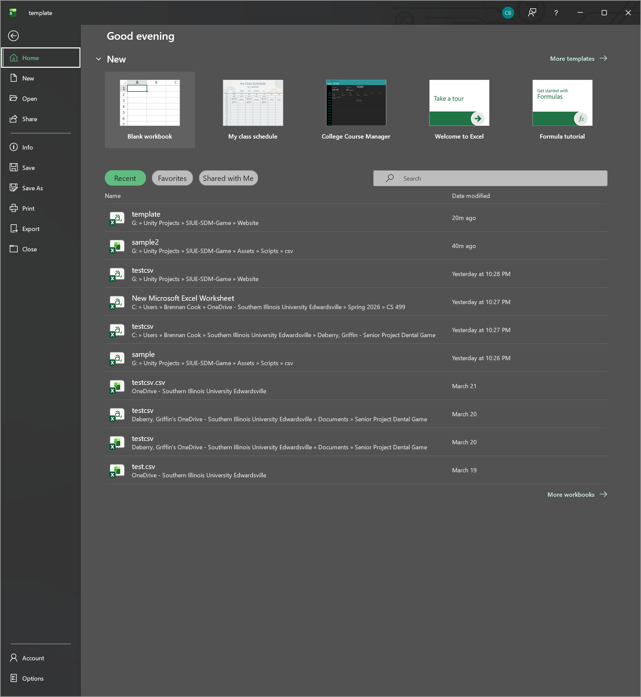
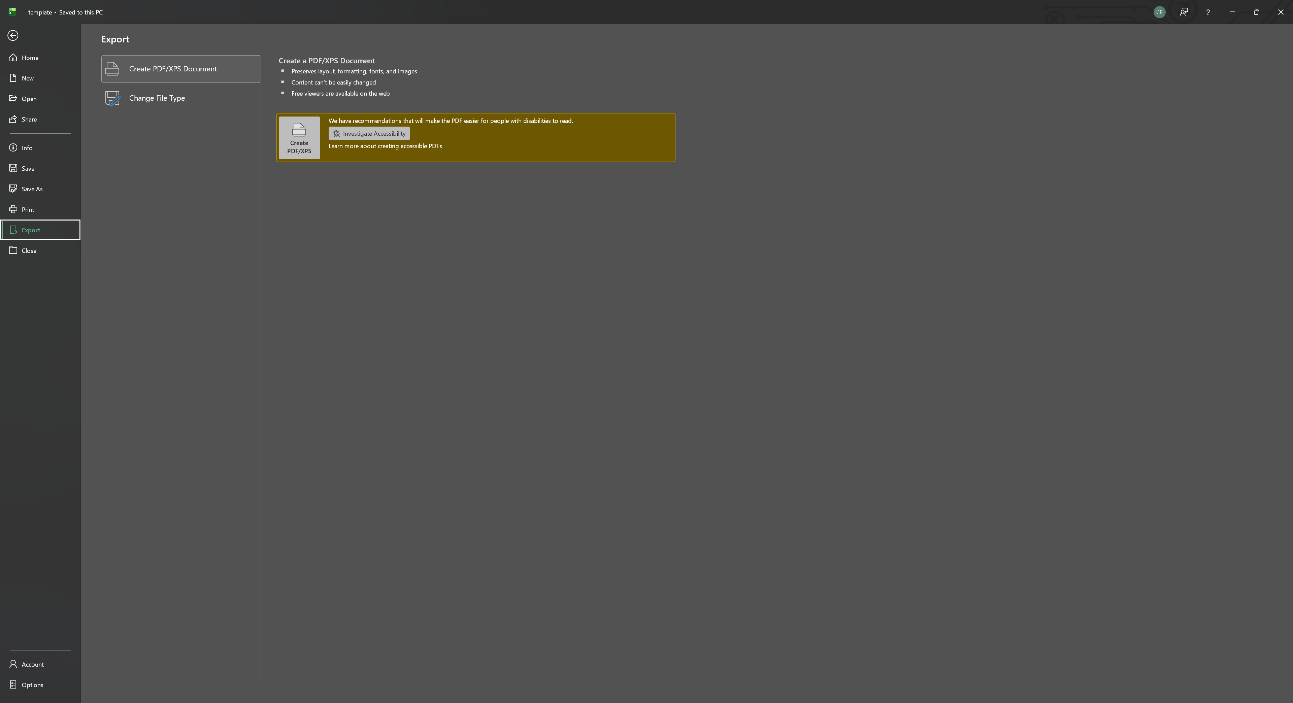
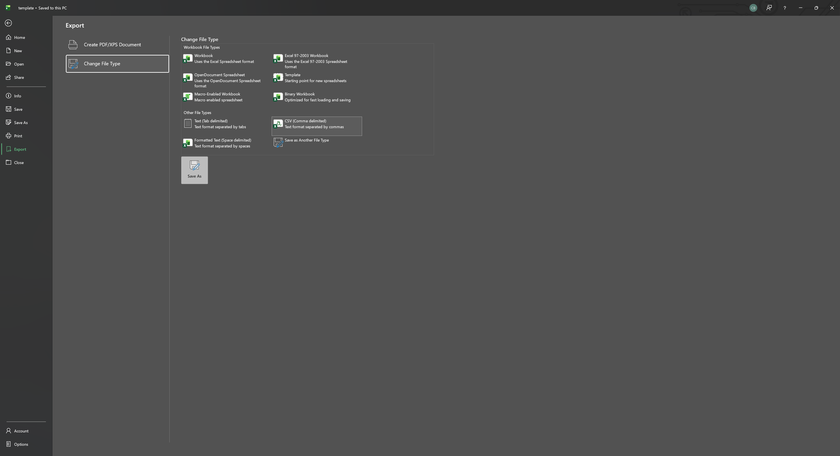
Next you will need to login to the CSV upload page to send the file over to the database for storage. https://103-89-14-188.cloud-xip.com/csvlogin.html use this link to login with administrator credentials and you will be sent to the upload page.
Then click on the Choose File button, select your CSV file, and click Upload to send your file to the database.
To test the results run the project logged in with a student account and run through the level in which modifications were made.

